Task 9 – Evidence Report
Failure-Injection Testing for the DSYS601 Alerting Rules
Student | Kabir Singh Thukrai
Student ID | 99281336
Course | BCIS309 – Work Integrated Learning Project
Task | Task 9 – Failure-injection testing (CrashLoopBackOff, memory, pod not-ready, node pressure)
Tests | 3 test pods and 2 scripts in the tests/ folder; re-test pods in ~/task9-tests/ on the fresh VM
Repository | https://github.com/kat0870/dsys601-k8s-observability-lab
Date | 29 September 2026 (re-tested 4 October 2026)

1. What this task was about
In Task 8 I showed the four alerts stay quiet on a healthy app. In Task 9 I broke things on purpose to check that each alert goes Pending, then Firing, reaches Alertmanager, and clears once the problem is fixed.
I used separate test pods in the demo-app namespace instead of breaking the real frontend, api or redis. All times below are NZ time.
Alert | Test
DSYS601PodCrashLooping | tests/crashloop-test.yaml
DSYS601ContainerMemoryNearLimit | tests/memory-test.yaml
DSYS601PodNotReady | tests/notready-test.yaml
DSYS601NodeUnderPressure | tests/node-pressure-start.sh and node-pressure-stop.sh

In section 6 I repeated the tests on 4 October on a fresh VM, with Alertmanager evidence for every alert.

2. CrashLoopBackOff test
The test pod runs for 5 seconds and then exits with an error, so Kubernetes keeps restarting it. The pod kept switching between Running, Error and CrashLoopBackOff (Figure 1), which is why the rule uses max_over_time over 5 minutes.
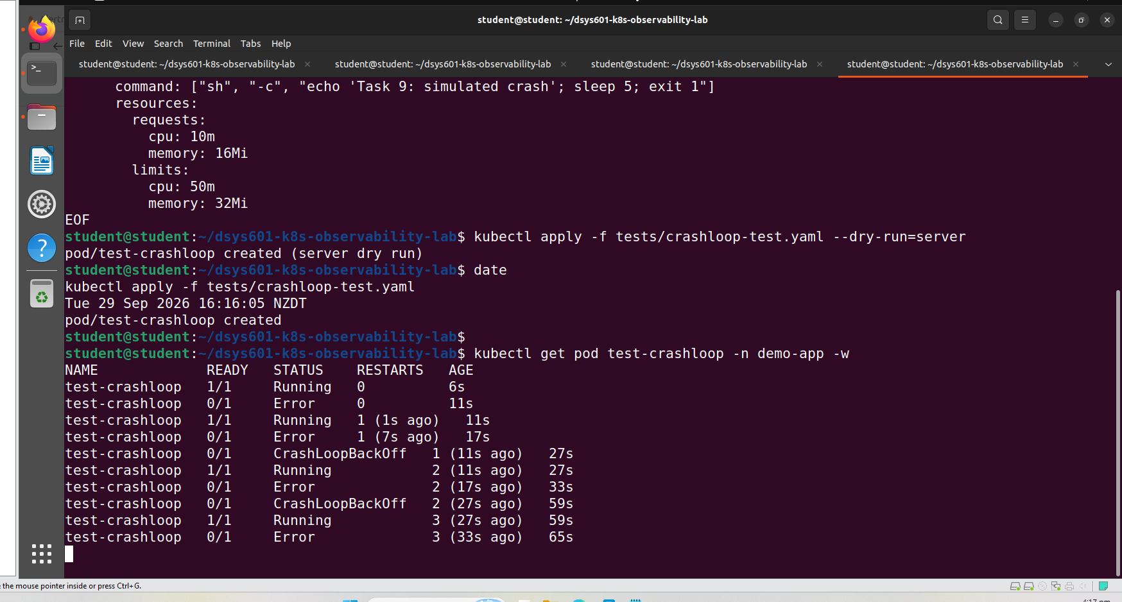
Figure 1. Test pod cycling between Running, Error and CrashLoopBackOff
The alert fired after about 8 minutes instead of 5. In the first few minutes the CrashLoopBackOff waits were shorter than the 30 second scrape interval, so Prometheus did not record them until 16:19. The pod not-ready alert also fired, which is expected because a crashing pod is not ready (Figures 2 and 3).
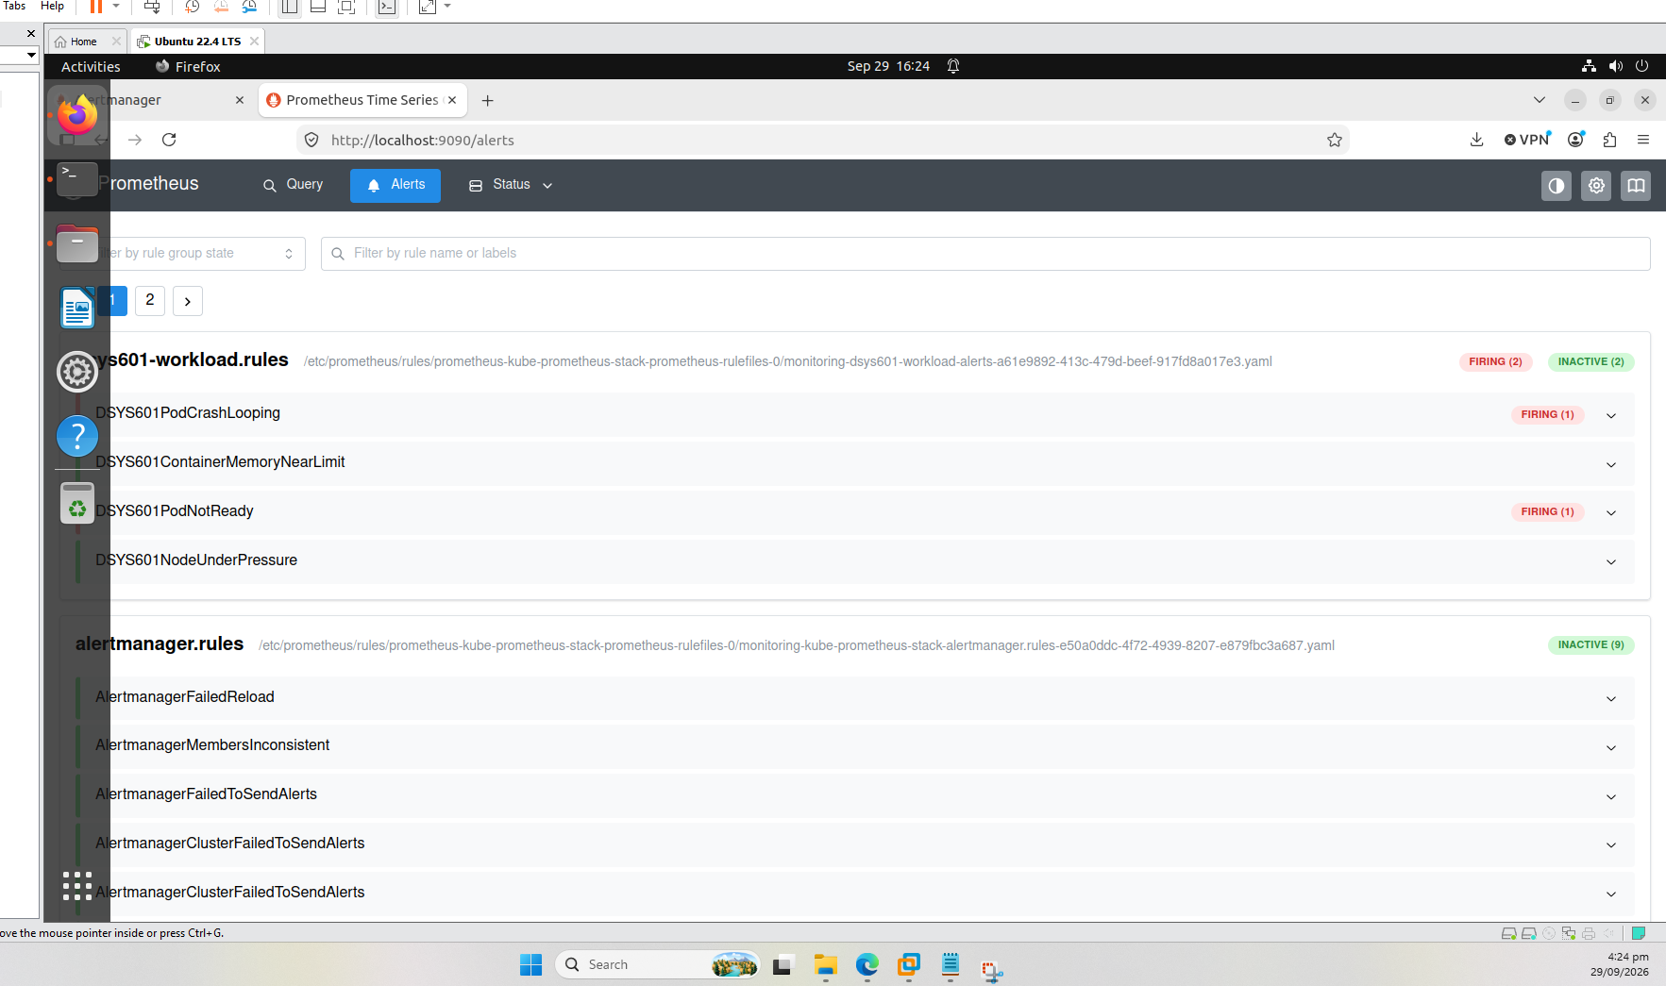
Figure 2. Both alerts firing in Prometheus
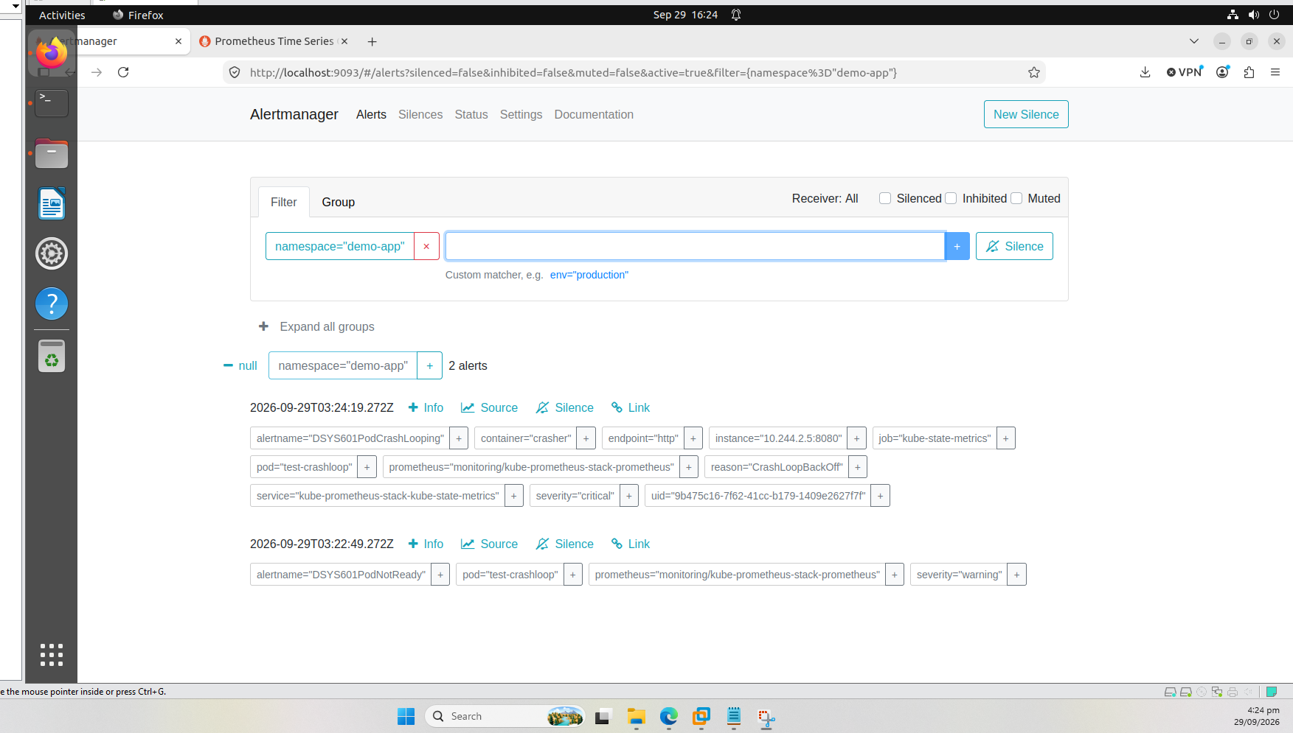
Figure 3. Both alerts received by Alertmanager

3. Memory test
The test pod has a 100Mi memory limit and fills 92Mi of it, then holds it. It was at 92.6% of its limit while the other containers stayed under 4% (Figure 4).
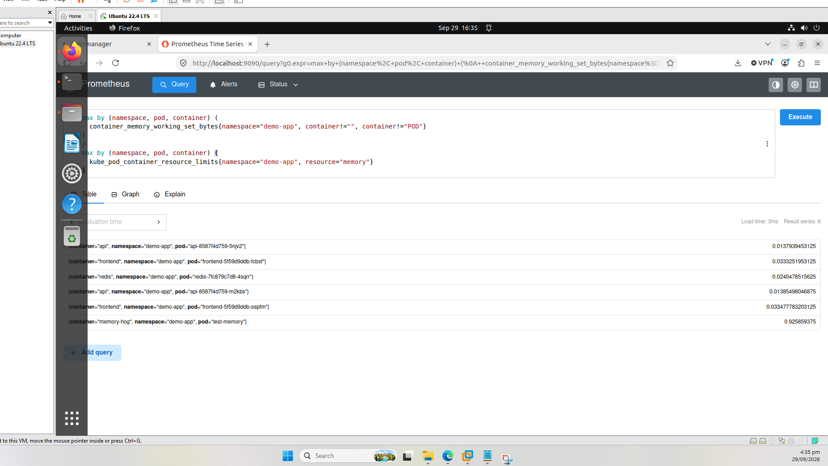
Figure 4. Test pod at 92.6% of its memory limit
The alert went Pending straight away and fired exactly 10 minutes later. It was the only alert that fired, because the pod was healthy and Ready (Figures 5 and 6).
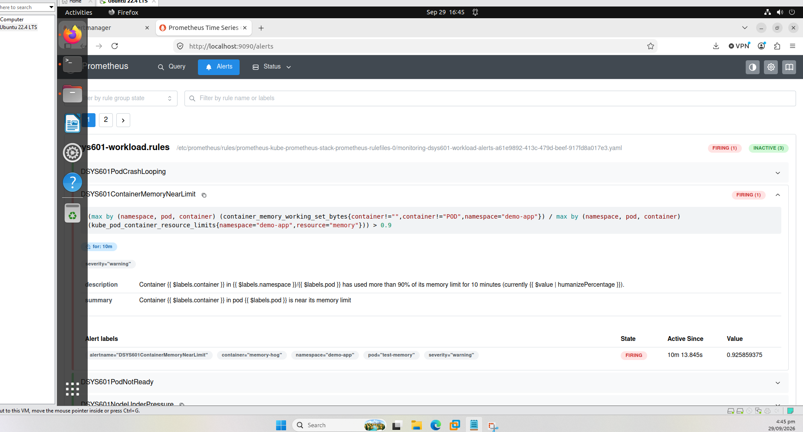
Figure 5. Memory alert firing in Prometheus
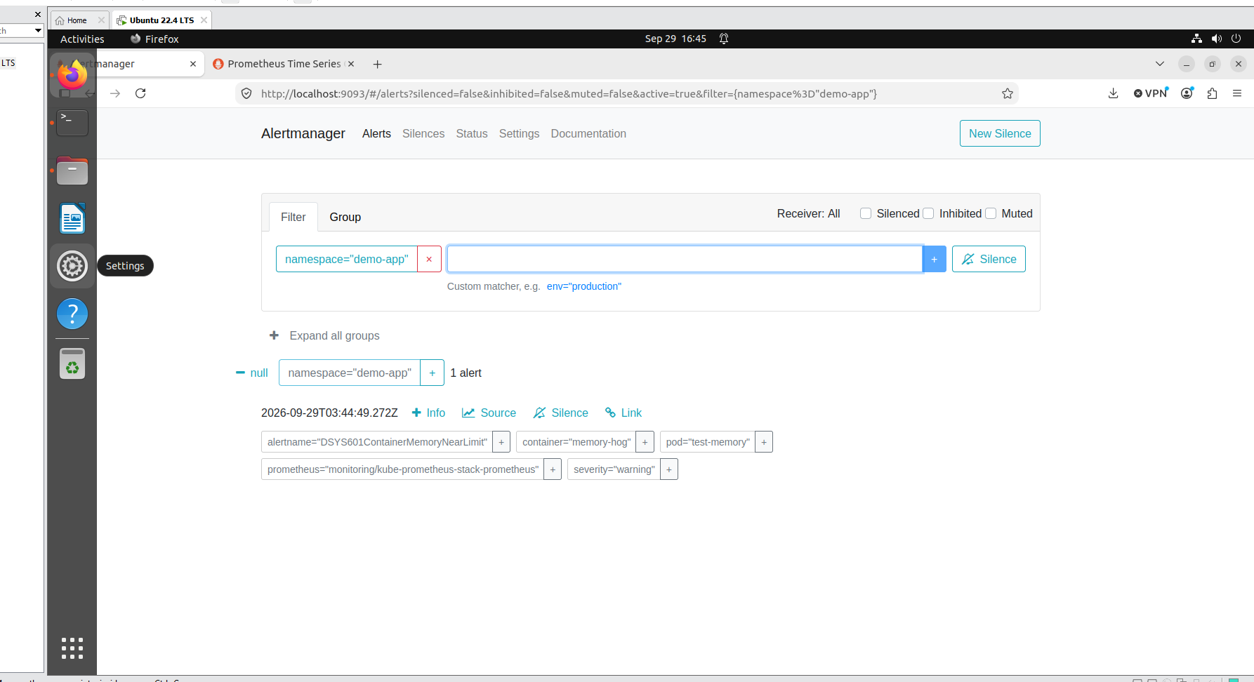
Figure 6. Memory alert received by Alertmanager

4. Pod not-ready test
The test pod runs normally but has a readiness check that always fails. Kubernetes showed it as Running with 0 restarts, but never Ready, and logged the failed readiness check (Figure 7).
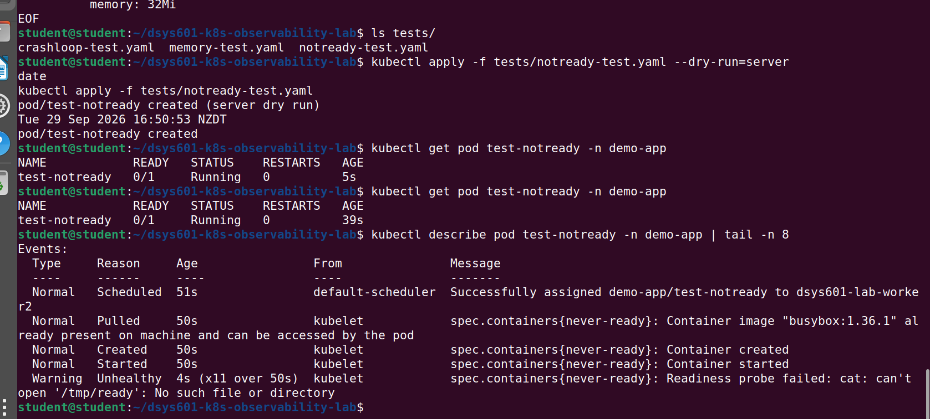
Figure 7. Pod running but not ready, with the failed readiness check
This time only the not-ready alert fired. The CrashLoop alert stayed quiet because nothing was crashing (Figure 8).
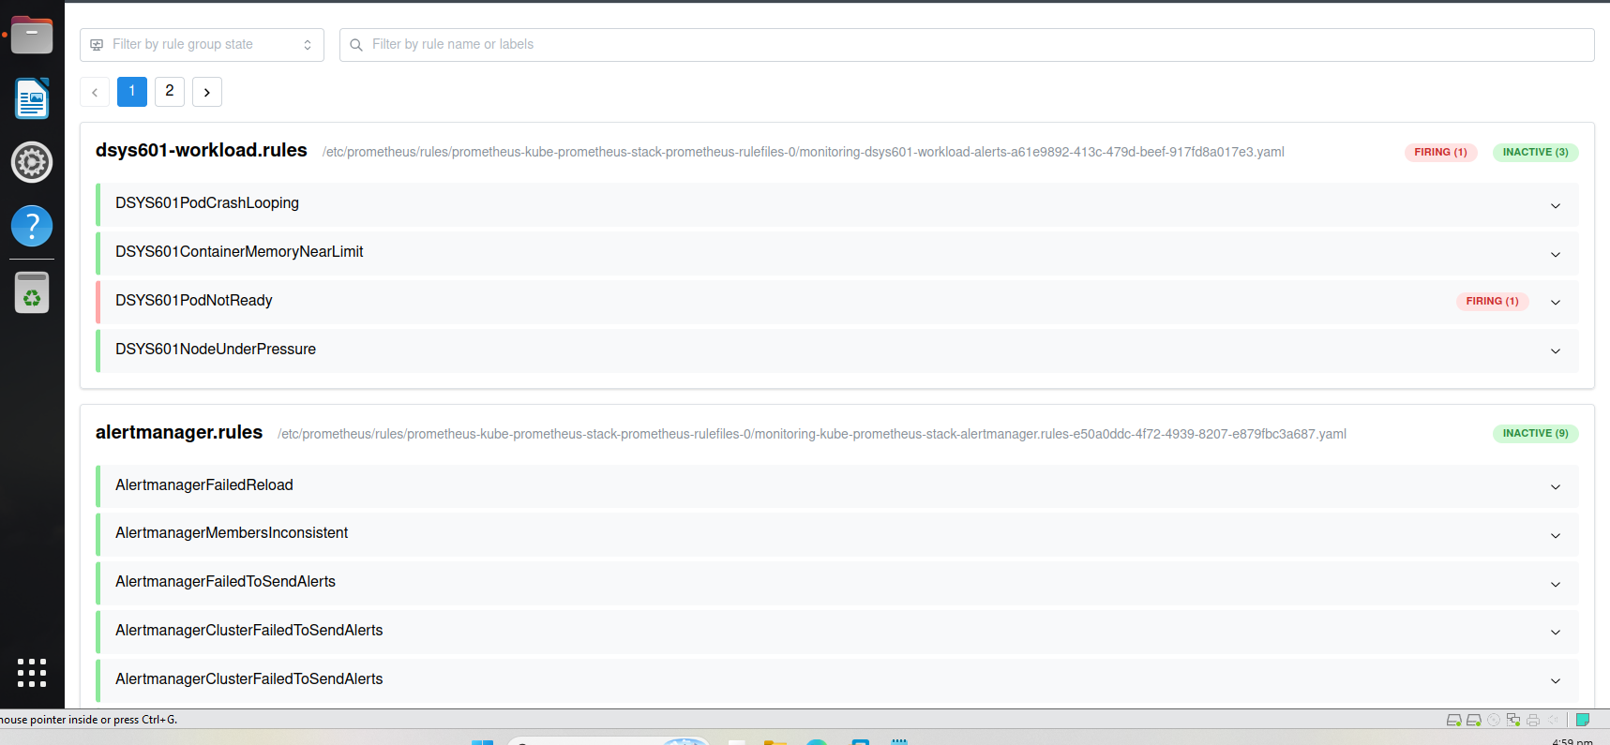
Figure 8. Not-ready alert firing on its own
After I deleted each test pod, all the alerts cleared (Figure 9). Alertmanager took a minute or two longer than Prometheus to clear.
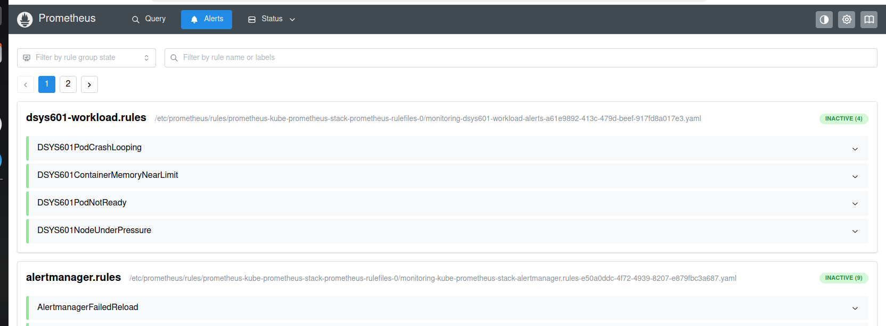
Figure 9. All four rules back to inactive after the pod tests

5. Node pressure test
My Task 8 report said I would test this alert with promtool. promtool only checks the rule logic and does not show a live alert, so I tested it live instead by changing a kubelet threshold on a node.
Causing real disk or memory pressure could freeze my only VM. Instead, the start script adds a soft disk threshold to the kubelet on worker2, with a 1 hour grace period. The node reports DiskPressure for real, but nothing is evicted during the test. The stop script puts the original settings back.
What went wrong first
My first try used a 30% threshold and DiskPressure stayed False. The kubelet measures a different disk to the one I checked, and it had much more free space, so 30% was never reached. I raised the threshold to 90%. A few early runs were also stopped too soon, or the Alertmanager port-forward was not running.
Final run
With the 90% threshold loaded, worker2 reported DiskPressure and got the disk-pressure taint (Figures 10 and 11).
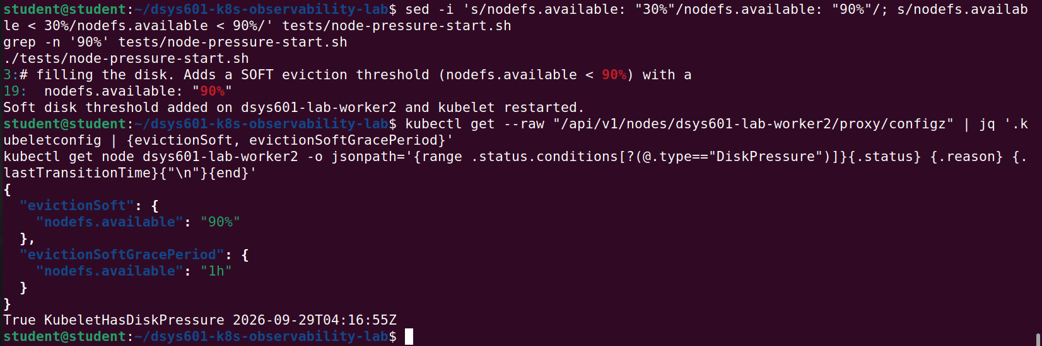
Figure 10. 90% threshold loaded and DiskPressure True
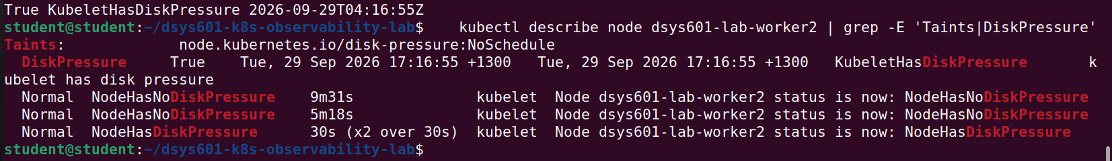
Figure 11. Disk-pressure taint and node events
The alert went Pending at 17:36:19 and fired 10 minutes later at 17:46:19, when it also reached Alertmanager (Figure 12).
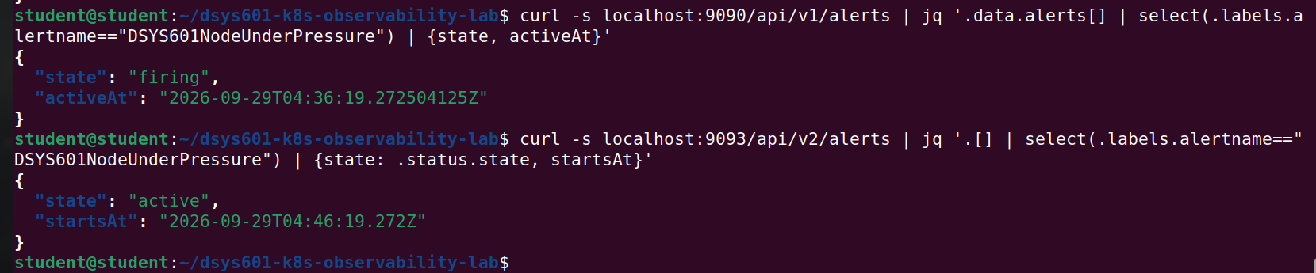
Figure 12. Node alert firing in Prometheus and active in Alertmanager
I ran the stop script at 17:50. DiskPressure went back to False, the taint was removed, and the alert cleared (Figure 13).
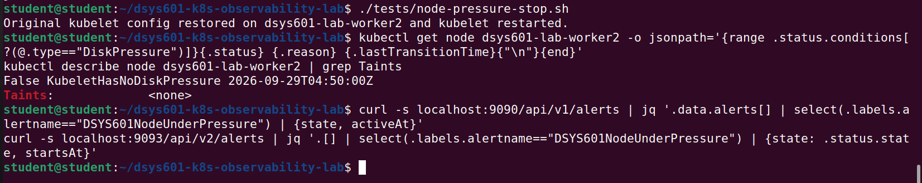
Figure 13. Node recovered and alert cleared

6. Re-test on the fresh VM (4 October)
On 4 October I ran all four tests again on the fresh-test VM and took a Prometheus and an Alertmanager screenshot for each alert. I also added a test for a container going over its memory limit, and changed the node test to memory pressure.
Alertmanager shows times in UTC, so I have converted them to NZ time (UTC+13). Its receiver is set to "null", so alerts arrive there but are not sent anywhere.
Pod not-ready
The pod's readiness check always fails. The alert fired at about 14:45 and reached Alertmanager at 14:45:17.
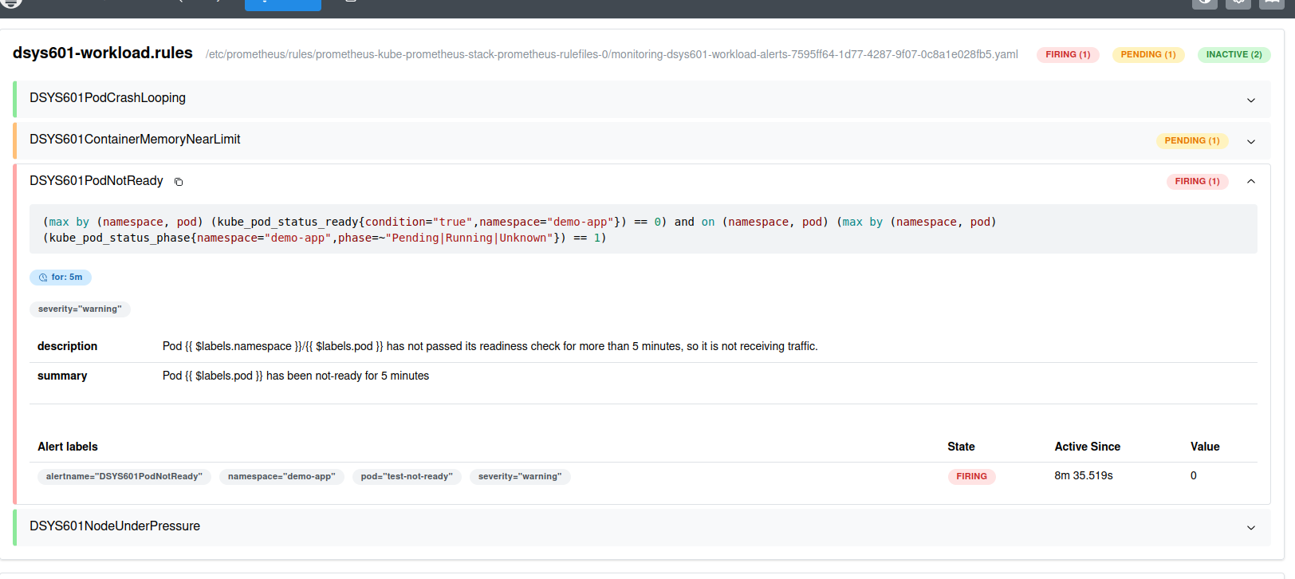
Figure 14. Pod not-ready alert firing in Prometheus
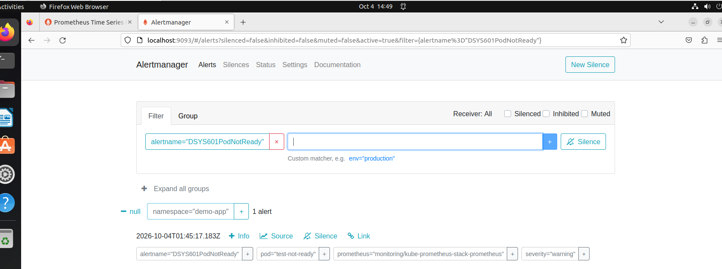
Figure 15. Pod not-ready alert in Alertmanager
Memory near limit
The pod fills 120M of a 128Mi limit (94%). The alert fired at about 14:50 and reached Alertmanager at 14:50:17.
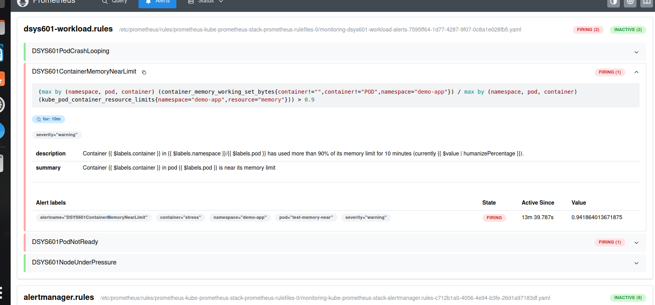
Figure 16. Memory near-limit alert firing in Prometheus
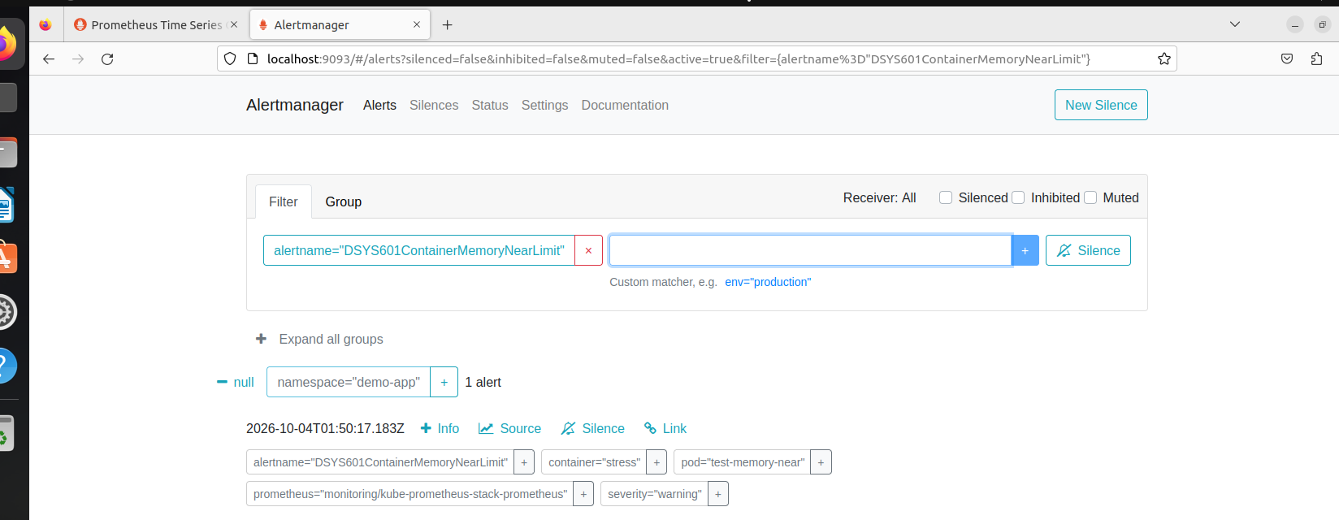
Figure 17. Memory near-limit alert in Alertmanager
Memory over the limit (new test)
This pod tries to use 200M with a 128Mi limit. It was killed with exit code 137, but Kubernetes showed the reason as "Error" instead of "OOMKilled" (Figure 18). The kernel log confirms it was the memory limit. At 14:57:09 it killed the stress process at about 126.6 MiB (Figure 19).
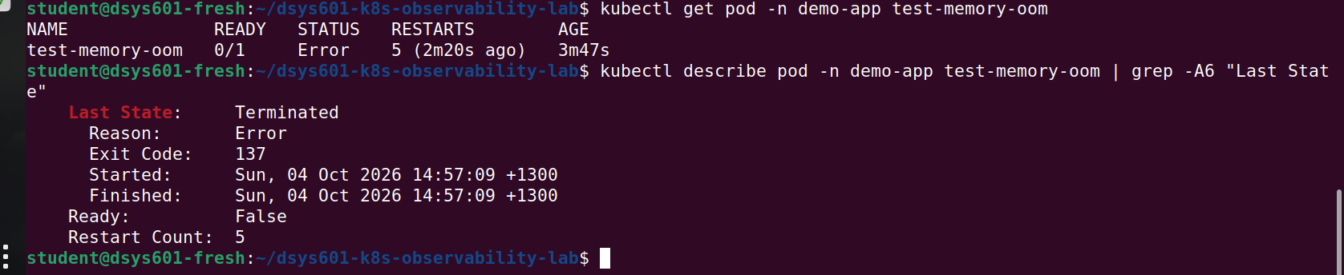
Figure 18. Memory test pod killed with exit code 137
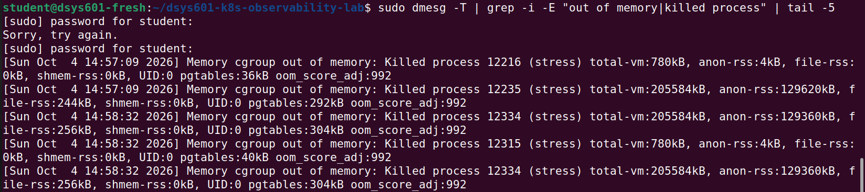
Figure 19. Kernel log showing the memory limit kill
The pod kept restarting, so the CrashLoop alert fired and reached Alertmanager at 15:05:17 (Figure 20). The memory alert does not catch this case, because the container is killed before it has been near the limit for 10 minutes.
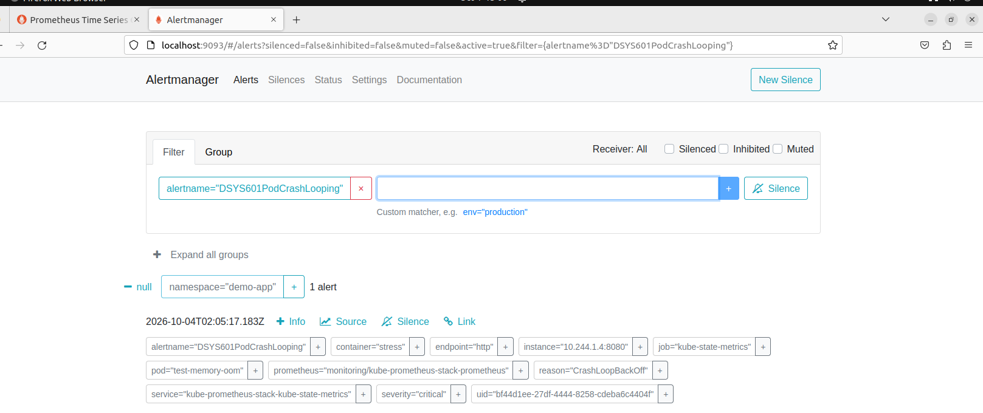
Figure 20. CrashLoop alert in Alertmanager after the memory kills
Node pressure (memory, simulated)
Using up real memory could freeze the VM and evict Prometheus or Alertmanager, which I needed to see the alert. So instead I raised the kubelet's eviction threshold on the control-plane to 7.5Gi, which made it report MemoryPressure. The disk test in section 5 ran on worker2 and evicted nothing, but this test could evict pods, so I used the control-plane instead of a worker. The two workers run Prometheus, Grafana and Alertmanager.
I hit two problems on the way. My first value, 20Gi, was more than the node's memory, so the kubelet would not start. Restarting the kubelet also failed with "too many open files" until I raised the VM's inotify limits. I have added that fix to install-tools.sh.
MemoryPressure went True at 15:25. The alert went Pending, fired 10 minutes later, and reached Alertmanager at 15:35:17 (Figures 21 and 22).
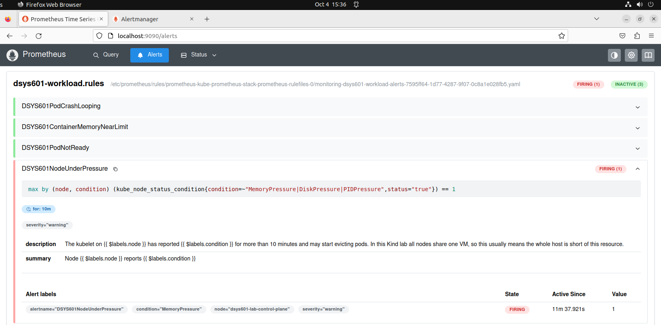
Figure 21. Node alert firing in Prometheus
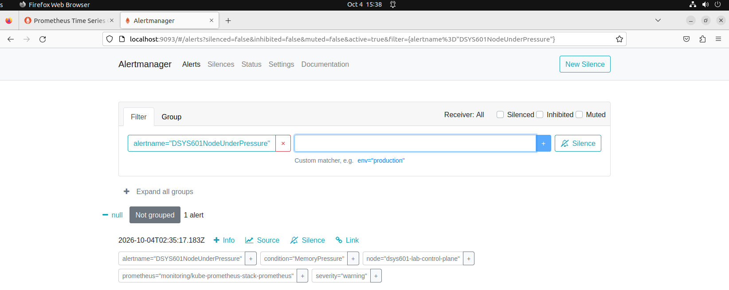
Figure 22. Node alert in Alertmanager
During the test the kubelet left critical pods alone but evicted node-exporter 11 times, because it has no memory request (Figure 23). This meant the node's metrics were missing while it was under pressure. Giving node-exporter a memory request would fix this.
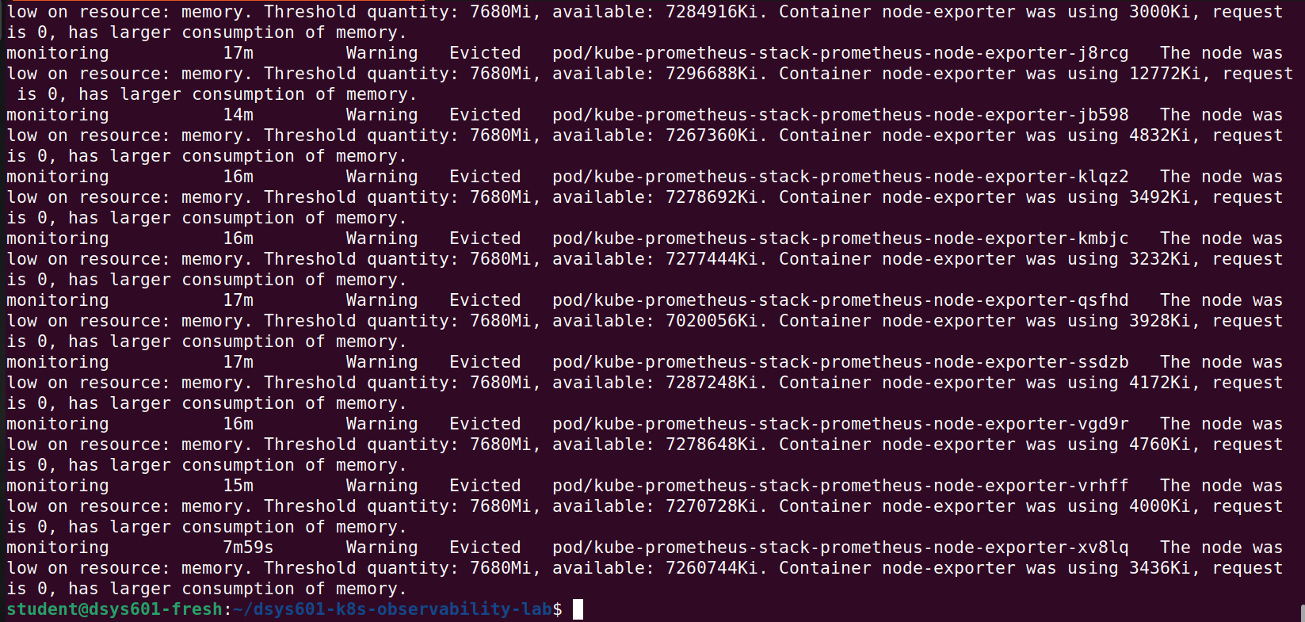
Figure 23. node-exporter evicted repeatedly on the control-plane
At about 15:40 I put the original kubelet config back. MemoryPressure went back to False, I removed two failed pods left over from the test, and verify-lab.sh passed all 11 checks (Figure 24).
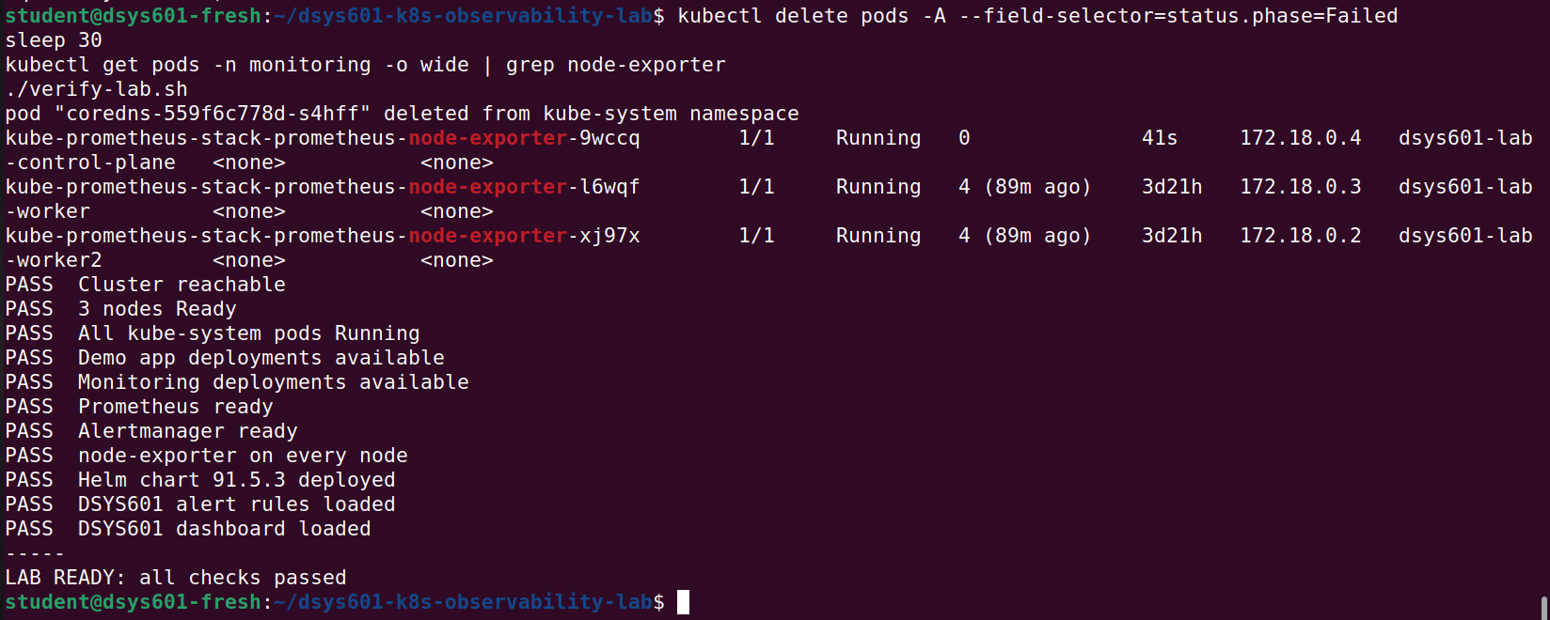
Figure 24. Lab back to normal, verify-lab.sh 11/11

7. Where this leaves Task 9
First run (29 September)
Alert | Started | Fired | Cleared
CrashLoopBackOff | 16:16 | 16:24 (about 8 min) | by 16:32
Memory near limit | 16:34 | 16:44 (10 min) | by 16:48
Pod not-ready | 16:50 | 16:56 (about 5 min) | by 17:01
Node pressure | 17:36 | 17:46 (10 min) | about 17:51

Re-test (4 October)
Alert | Test | Fired | In Alertmanager
Pod not-ready | test-not-ready | about 14:45 | 14:45:17
Memory near limit | test-memory-near | about 14:50 | 14:50:17
CrashLoop (memory over limit) | test-memory-oom | about 15:05 | 15:05:17
Node pressure (memory) | kubelet threshold on control-plane | about 15:35 | 15:35:17

In both runs all four alerts fired and reached Alertmanager. The first-run test files are in the tests/ folder and pushed to GitHub (Figure 25).
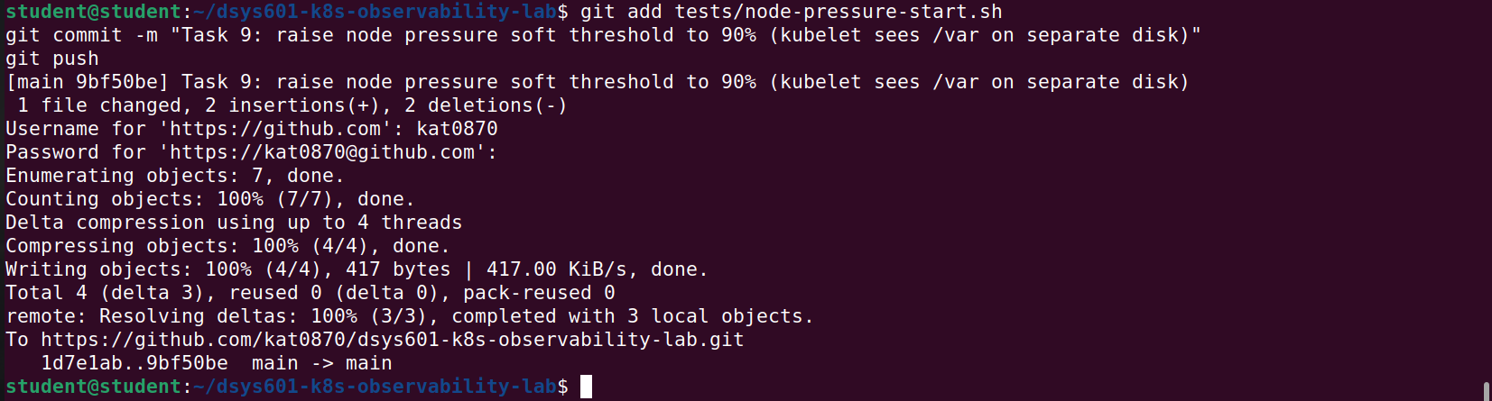
Figure 25. Final Task 9 commit pushed to GitHub
Things I learned:
The 30 second scrape interval can delay the CrashLoop alert by a few minutes when a pod crashes quickly.
A container that goes over its memory limit is caught by the CrashLoop alert, not the memory alert, and the kernel log is the reliable way to confirm the kill.
node-exporter should have a memory request so it is not evicted during memory pressure.
Repository: https://github.com/kat0870/dsys601-k8s-observability-lab

